ljifoM sfo{kflnsfsf] lgoldt a}7\sdf pkl:yt x'g] af/]df .

>L sfo{kflnsfsf] ;Dk"0f{ ;b:o Ho"x?,

Gff/fo0f gu/kflnsf gu/ sfo{kflnsfsf] sfof{no,b}n]v .
olx ldlt @)&%.!.!# ut]sf lbg o; gf/fo0f gu/kflnsfsf] sfof{nodf tklznsf] ;do,ldlt / :yfgdf sfo{kflnsfsf] a}7\s a:g] ePsf]n] pkl:yltsf] nflu ;Dk"0f{ sfo{kflnsfsf ;b:o Ho"x?nfO{ hfgsf/Lsf] nflu cfb]zg';f/ cg'/f]w 5 .
tklzn
ldltM@)&%.!.!# ut]
;doM lbpF;f] !M)) ah]
:yfgM gf/fo0f gu/kflnsfsf] ;efxn .

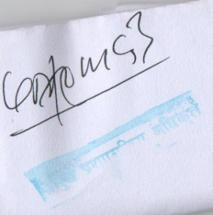
k|d'v k|zf;sLo clws[t

